Introduction
This project will assist people with exploring better facilities around their neighborhood and making data-driven decisions when selecting from the neighborhoods in Scarborough, Toronto. With COVID-19 causing many people to consider moving from their current neighborhoods, there is a need to ease the level of effort required to research for housing prices and school reputations. This project is meant to provide this capability to those people as they try to assess new neighborhoods by understanding the ease of access to cafes, schools, supermarkets, pharmacies, malls, theatres, hospitals, etc.
Specifically, this project will focus on developing a thorough analysis of features for a people migrating to Scarborough through a comparative analysis between neighborhoods. The features include median housing price, school ratings, crime rates, road connectivity, weather conditions, emergency management facilities, water resources. This will help people gain awareness of the area before investing in moving to a new city/state/country to start a new life.

Problem to be Solved
The primary focus of this project is to research neighborhoods in a new city for people considering moving. This takes into account the social makeup of the neighborhood and connectivity to airports, buses, city centers, markets, and other nearby daily needs.
- Sorted list of houses in terms of housing prices in an ascending or descending order
- Sorted list of schools in terms of location, fees, rating and reviews

Data Source
Data Link: https://en.wikipedia.org/wiki/List_of_postal_codes_of_Canada:_M
I will use the Scarborough dataset from Wikipedia used in the Week 3 project. Dataset consists of latitude and longitude, zip codes.

FourSquare API Data
We will need data about different venues in different neighborhoods of that specific borough. In order to gain that information, we will use "Foursquare" locational information. Foursquare is a location data provider with information about all manner of venues and events within an area of interest. Such information includes venue names, locations, menus and even photos. As such, the foursquare location platform will be used as the sole data source since all the stated required information can be obtained through the API.
After finding the list of neighborhoods, we then connect to the Foursquare API to gather information about venues inside each and every neighborhood. For each neighborhood, we have chosen the radius to be 100 meters.
The data retrieved from Foursquare contained information of venues within a specified distance of the longitude and latitude of the postcodes. The information obtained per venue as follows:
- Neighborhood
- Neighborhood Latitude
- Neighborhood Longitude
- Venue
- Name of the venue e.g. the name of a store or restaurant
- Venue Latitude
- Venue Longitude
- Venue Category

Map of Scarborough
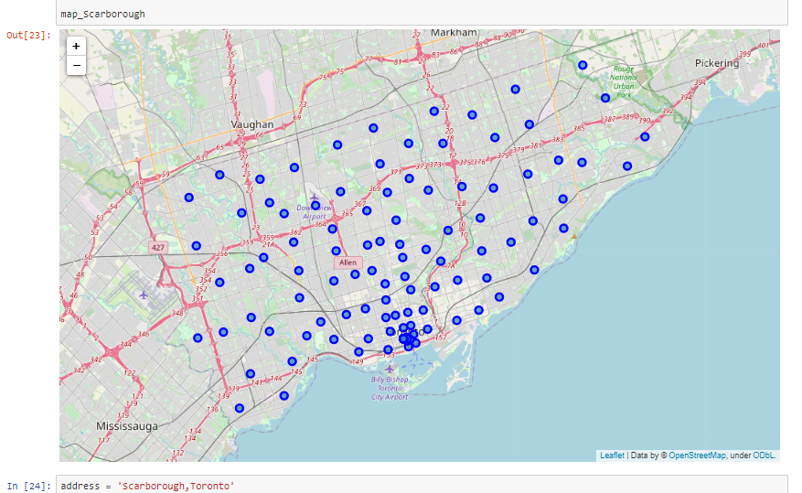

Methodology Section
In order to allow users to compare neighborhoods, we will segment and group them into clusters to find similar neighborhoods and allow a more apples to apples comparison. Doing this will require us to cluster data using a form of unsupervised machine learning; k-means clustering algorithm.
First, we will find the most commonly visited venues in each neighborhood using the FourSquare API. Then we will use k-means clustering to cluster neighborhoods into three different clusters. However, due to http request limitations the number of places per neighborhood parameter would be set to 100 and the radius parameter would be set to 500, in order to keep from inferring any costs. This can be modified later to account for investor funding, ad revenue, and/or public/municipal grants.

Using K-Means Clustering Approach
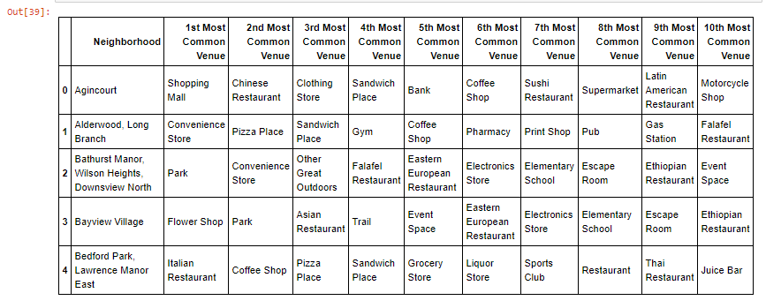
Most Common Venues near Neighborhood
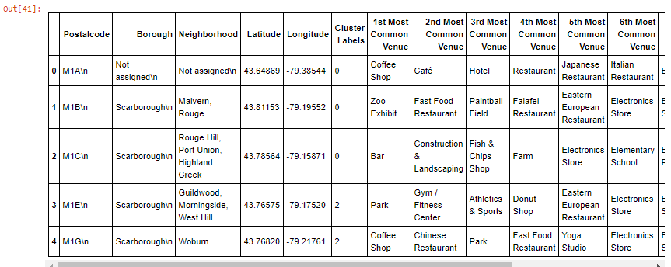

Results Section
Map of Clusters in Scarborough
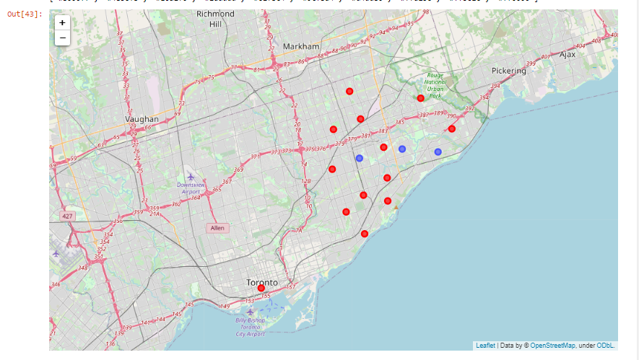

Average Housing Price by Clusters in Scarborough
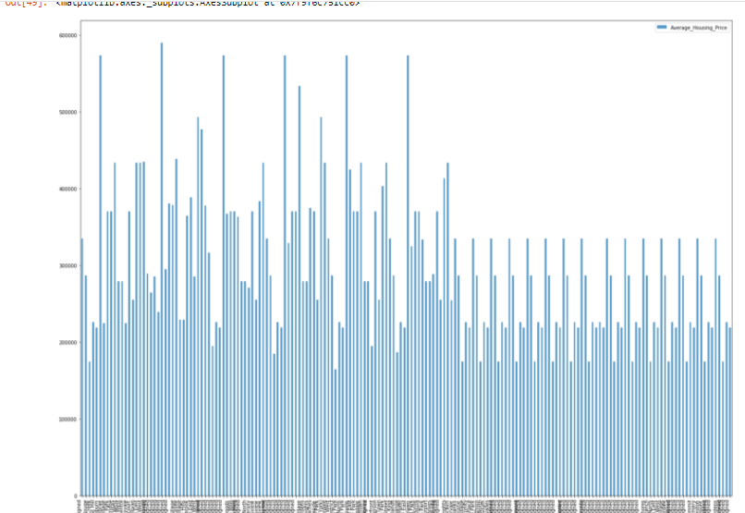

School Ratings by Clusters in Scarborough
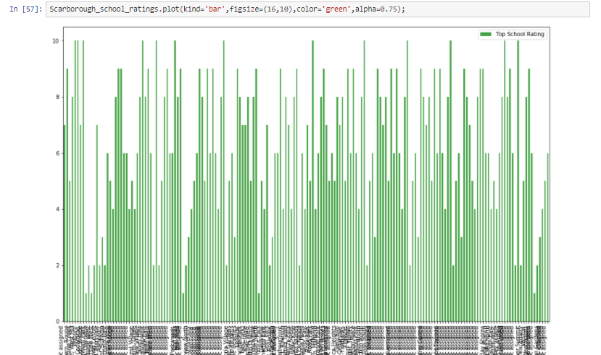

The Location
Scarborough is a popular destination for new immigrants in Canada to reside. As a result, it is one of the most diverse and multicultural areas in the Greater Toronto Area. Our data clearly shows that while there are still very financially exclusive neighborhoods with great schools, there are still many solid middle class neighborhoods with both affordable housing and great schools. Additionally, these neighborhoods are still serviced by a diverse group of ethnic restaurants, shopping facilities, and public services. This allows us to make a data based inference that there are many multi-cultural neighborhoods which will welcome people from across the globe while also providing the necessities to keep the populous safe and secure. Although immigration will likely continue to be a hot topic in the future with more governments seeking to manage the influx of immigrants and refugees, the general trend of immigration into Canada seems to be sustainable and advantageous for the time being.

Discussion Section
My biggest takeaway from this exercise was the overall affordability of Scarborough (compared to my home in the Washington DC metro area) and the quality of the schools. While I know many people aspire to move to my neighborhood due to our proximity/dependency on Federal money to support the major economic drivers in conjunction with similarly diverse neighborhoods, I also know that we are on par with Manhattan and Palo Alto as far as cost of living. While the real estate is still cheaper, per square foot, it isn’t by that much compared to what NYC and Silicon Valley had to offer pre-COVID. With that in mind, in addition to the current political/social challenges in the US with our current President, I would actually encourage any non-US-resident and many mid-tier US city citizens to consider moving across the border to Canada. While anecdotal knowledge may say one thing, the data is clearly telling us a very different tale. I would be very interested in running a compare and contrast study between Scarborough and the DC Metro area later to make an apples to apples comparison.

Conclusion Section
In conclusion, this project presented a unique opportunity to combine the technical capabilities which I developed over the eight courses of this technical certification with many of the real-world challenges I am facing in my life as the CEO of a management consulting firm. In addition to understanding the power and flexibility of modern development languages and their ability to interact with structured and unstructured data, this project helped me understand how easy it is to leverage data driven decision making into day to day decision making.
As far as this report goes, it is quite easy to see that Scarborough offers opportunities that have traditionally only been accessible in largely financially exclusionary cities at a price point that is far more reasonable than many “tier 1” cities like NYC, San Francisco, DC, and LA. While the data could still use another one or two more finely tuned culls to better understand the true cost of living, specifically focusing on average salaries and major employers, it is clear to see that there really is something to be said about the city of Scarborough.

